**STAT 441/541 Statistical Methods II**

**Fun with an Effects Model and Hypotheses for One-Way ANOVA**

**Based on Exercise 8.32**

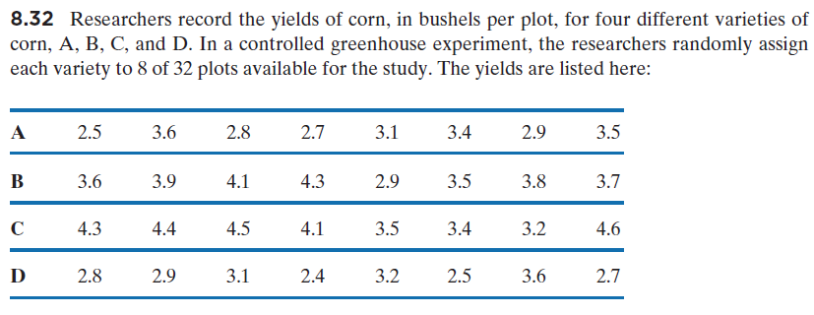

(a) For this scenario, state the treatment effects model, describe all terms in the model, and give values for all subscripts (the subscripts are *i* and *j* in the model):

First, note that there are *t*=4 treatments (corn varieties) and *n*=8 observations for each treatment

$$y_{ij}=μ+τ_{i}+ε_{ij}$$

where

$y_{ij}$ is the *j*th observation for the *i*th corn variety

$μ$ is the overall mean

$τ_{i}$ effect of the *i*th corn variety

$ε_{ij}$ is the random error for the *j*th observation for the *i*th corn variety

*i*=1,2,3,4 since *t*=4

*j*=1,2,3,4,5,6,7,8 since *n*=8

(b) What are the hypotheses for the One-Way ANOVA test?

Note that we are using an effects model and there are four corn varieties, so the hypotheses are:

$H_{o}: τ_{1}=τ_{2}=τ_{3}=τ_{4}=0$

$H_{a}:At least one τ_{i}≠0$

(c) What are the hypotheses for the Shapiro-Wilks test of normality?

Note that the errors in the model are represented by $ε_{ij}$ and we are testing if these are normally

distributed:

$H_{0}:the errors are from a normal distribution$

$H_{a}:the errors are not from a normal distribution$

The Appendix on the next page provides more details about the effects model and subscripts:

APPENDIX

For the effects model given in part (a), each observation is denoted by the following entries in the table. We see that the model is an efficient way to represent many observations.

|  |  |  |  |  |  |  |
| --- | --- | --- | --- | --- | --- | --- |
| **Corn Variety** | **i** | **j** | $$y_{ij}$$ | $$μ$$ | $$τ_{i}$$ | $$ε_{ij}$$ |
| A | 1 | 1 | $$y_{11}$$ | $$μ$$ | $$τ_{1}$$ | $$ε_{11}$$ |
| A | 1 | 2 | $$y_{12}$$ | $$μ$$ | $$τ_{1}$$ | $$ε_{12}$$ |
| A | 1 | 3 | $$y_{13}$$ | $$μ$$ | $$τ_{1}$$ | $$ε_{13}$$ |
| A | 1 | 4 | $$y_{14}$$ | $$μ$$ | $$τ_{1}$$ | $$ε_{14}$$ |
| A | 1 | 5 | $$y_{15}$$ | $$μ$$ | $$τ_{1}$$ | $$ε_{15}$$ |
| A | 1 | 6 | $$y_{16}$$ | $$μ$$ | $$τ_{1}$$ | $$ε_{16}$$ |
| A | 1 | 7 | $$y_{17}$$ | $$μ$$ | $$τ_{1}$$ | $$ε_{17}$$ |
| A | 1 | 8 | $$y_{18}$$ | $$μ$$ | $$τ_{1}$$ | $$ε_{18}$$ |
| B | 2 | 1 | $$y_{21}$$ | $$μ$$ | $$τ_{2}$$ | $$ε_{21}$$ |
| B | 2 | 2 | $$y_{22}$$ | $$μ$$ | $$τ_{2}$$ | $$ε_{22}$$ |
| B | 2 | 3 | $$y_{23}$$ | $$μ$$ | $$τ_{2}$$ | $$ε_{23}$$ |
| B | 2 | 4 | $$y_{24}$$ | $$μ$$ | $$τ_{2}$$ | $$ε_{24}$$ |
| B | 2 | 5 | $$y_{25}$$ | $$μ$$ | $$τ_{2}$$ | $$ε_{25}$$ |
| B | 2 | 6 | $$y_{26}$$ | $$μ$$ | $$τ_{2}$$ | $$ε_{26}$$ |
| B | 2 | 7 | $$y_{27}$$ | $$μ$$ | $$τ_{2}$$ | $$ε_{27}$$ |
| B | 2 | 8 | $$y_{28}$$ | $$μ$$ | $$τ_{2}$$ | $$ε_{28}$$ |
| C | 3 | 1 | $$y_{31}$$ | $$μ$$ | $$τ_{3}$$ | $$ε_{31}$$ |
| C | 3 | 2 | $$y_{32}$$ | $$μ$$ | $$τ_{3}$$ | $$ε_{32}$$ |
| C | 3 | 3 | $$y_{33}$$ | $$μ$$ | $$τ_{3}$$ | $$ε_{33}$$ |
| C | 3 | 4 | $$y_{34}$$ | $$μ$$ | $$τ_{3}$$ | $$ε_{34}$$ |
| C | 3 | 5 | $$y_{35}$$ | $$μ$$ | $$τ_{3}$$ | $$ε_{35}$$ |
| C | 3 | 6 | $$y_{36}$$ | $$μ$$ | $$τ_{3}$$ | $$ε_{36}$$ |
| C | 3 | 7 | $$y_{37}$$ | $$μ$$ | $$τ_{3}$$ | $$ε_{37}$$ |
| C | 3 | 8 | $$y_{38}$$ | $$μ$$ | $$τ_{3}$$ | $$ε_{38}$$ |
| D | 4 | 1 | $$y_{41}$$ | $$μ$$ | $$τ_{4}$$ | $$ε_{41}$$ |
| D | 4 | 2 | $$y_{42}$$ | $$μ$$ | $$τ_{4}$$ | $$ε_{42}$$ |
| D | 4 | 3 | $$y_{43}$$ | $$μ$$ | $$τ_{4}$$ | $$ε_{43}$$ |
| D | 4 | 4 | $$y_{44}$$ | $$μ$$ | $$τ_{4}$$ | $$ε_{44}$$ |
| D | 4 | 5 | $$y_{45}$$ | $$μ$$ | $$τ_{4}$$ | $$ε_{45}$$ |
| D | 4 | 6 | $$y_{46}$$ | $$μ$$ | $$τ_{4}$$ | $$ε_{46}$$ |
| D | 4 | 7 | $$y_{47}$$ | $$μ$$ | $$τ_{4}$$ | $$ε_{47}$$ |
| D | 4 | 8 | $$y_{48}$$ | $$μ$$ | $$τ_{4}$$ | $$ε_{48}$$ |